Peppermint Smiles Art
Program title: Term Art Classes
Program activity type/artform: Drawing, sketching, painting.
Program description: Term-based art classes for children aged 5-15. At the end of the first ten-week term, participants would have an understanding of basic drawing and shading techniques, colour palettes and painting using different mediums (watercolours, acrylics) and surfaces.
My courses teach drawing and painting techniques through a variety of watercolour and acrylic paintings that we create together, along with lessons to help drawing and shading skills. This keeps the classes educational and entertaining at the same time for young children, and students can have the satisfaction and motivation of taking home their very own self-created paintings after most classes.
Acrylics and water colours are forgiving to work with, can provide a variety of effects and can be cleaned up with water – so perfect for beginners. Acrylics are made on canvases, are vibrant and opaque, and offer more qualities than watercolours. And the methods of application are different. As we progress through classes and terms, we will attempt art works which demand progressively higher drawing and painting skills and involve more detailing. We can also have classes with other forms like mixed media art, fluid painting etc.
Term1 Program outcomes: Basic understanding of drawing, shading and painting techniques.
Drawing skills including:
  - Light and shadow observation
  - Near and far object drawing
  - Still life drawing
  - Techniques to draw from observations
Painting skills including:
  - Understanding how pastels, watercolours and acrylics work
  - Colour tones and mixing
  - Brush techniques and varieties

Term1 Plan
Week One | Drawing and painting a banana:  Learning how to create a messy effect on a banana by using watercolour brown on yellow.  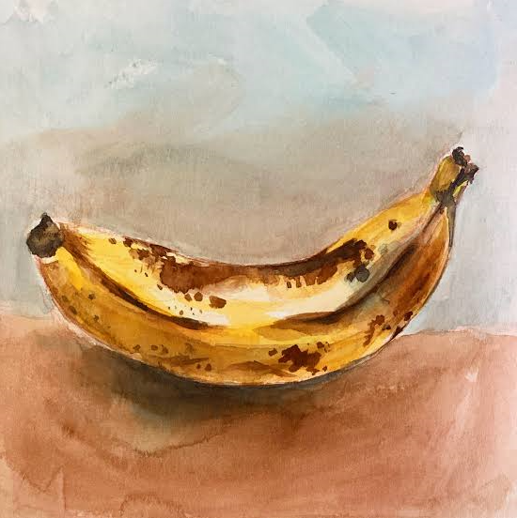
Week Two | Drawing and painting a cactus:  Mixing watercolour shades.  Creating a cactus painting by using different shades of green, yellow and brown in watercolours.  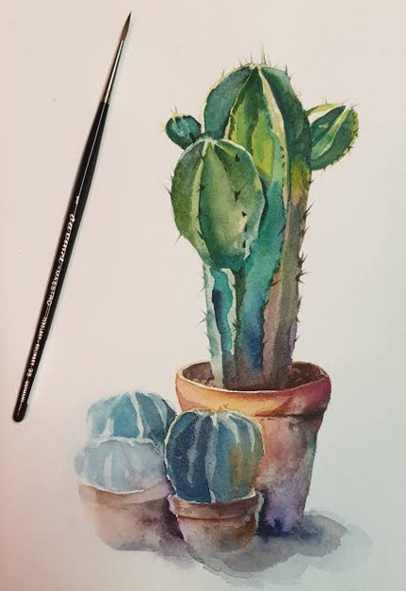
Week three | Drawing and painting citrus slices:  Understanding colour diversity.  Applying colour diversity while painting the insides of citrus fruits.  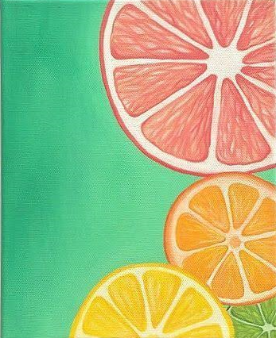
Week four | Drawing and shading a jug, cup & fruit:  Drawing and shading skills using pencils  Observation of light source and the shadow it casts on different shapes  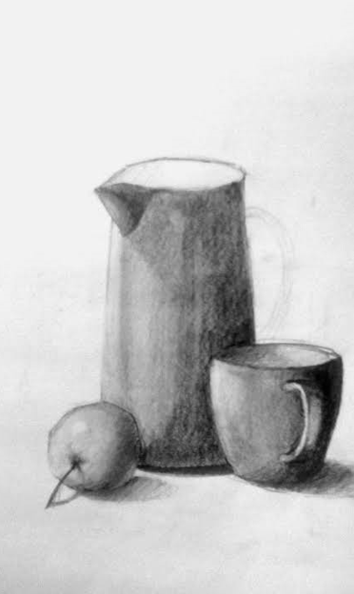
Week five | Drawing and painting a colourful fish  Introduction to wet on wet procedures to create a transparent look by using different colours and tones of water paints.  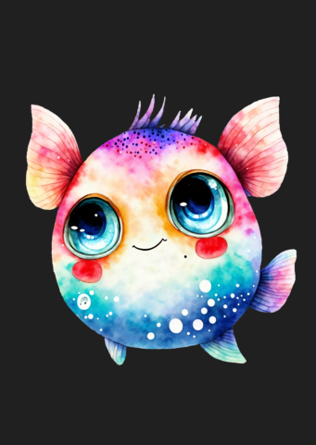
Week Six | Drawing and painting daytime beach with landscape  Learn how to create an ocean effect with acrylic paints  Explore different shades of deep water and daytime sky in the sun  How to paint crashing waves on sand  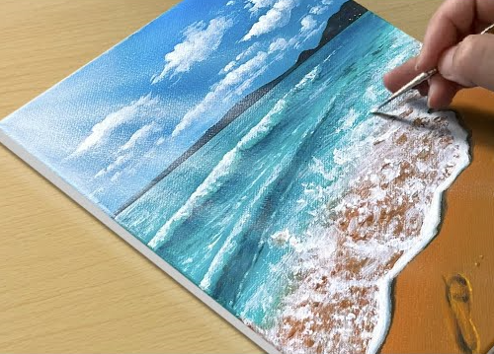
Week Seven | Drawing and painting an evening by the ocean with landscape:  Painting an evening sky with acrylic paints  Learning how to create shallow and deep water effects in low light  Shadow observation and shading skills  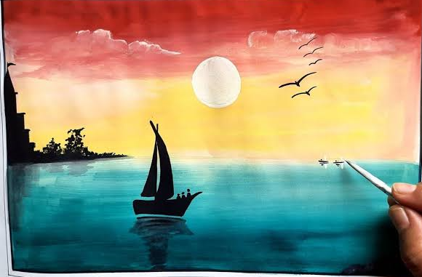
Week Eight | Still life leaf drawing  Exploring various shades of a leaf  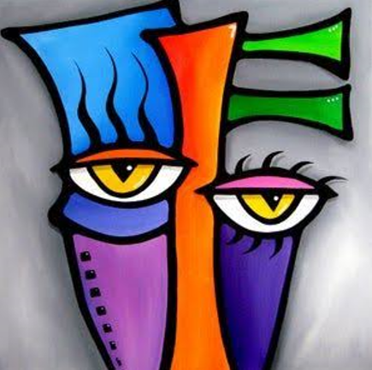
Week Nine | Making a composite artwork with different elements:  Learn to draw a fox, and to create a furry effect on him  Drawing and acrylic painting of various elements  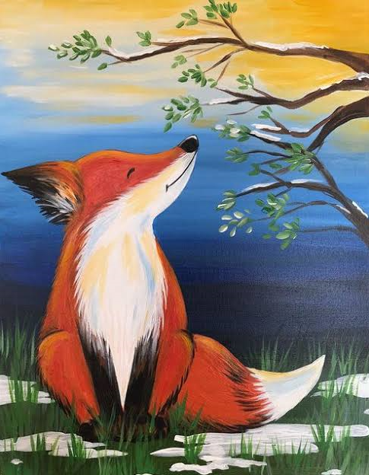
Week Ten | Preparing a mixed media art piece.  Students employ creativity to create the art work.  Layering of mediums.  Paint spreading.  Experimenting with collages.  Exploration of non visual elements.  Since the class is to encourage creativity and imagination in preparing the art work the finished piece might be different for each student.

